#include: <vector>, <utility>, <algorithm>, <iostream>, <fstream>, <algorithm>, <sstream>
#include “file.h”
String are array of char with (‘/0’) at end
.c_str()-return const char
std::vector <type>
std::pair<type, type>
int main(int argc, char* argv[])
std::string name(len, thing)
std::ifstream in_str(); (.good() return true if good)
std::ofstream out_str();
out_str.close();
stoi(string to int);
.substr(index,len);
.push_back(stuff)
&something - reference
-you want to const the get functions.
-pointers hold memory addresses, *means follow the pointer, no alias unless pass by reference
if ( p == q ) or if ( p != q ) are legal ways to compare pointers
-arrays point to a block of memory ++p moves to next location in the array.
for ( p=a; p<a+n; ++p ) loop through array with pointers.
std::sort (.begin(), .end(), function to return true or false )
std::sort(rooms.begin(), rooms.end());
std::vector<std::string>::iterator unique_rooms = std::unique(rooms.begin(), rooms.end());
rooms.resize(std::distance(rooms.begin(), unique_rooms));
-use new to put it on the heap, use delete to remove from heap.
while (!in_str.eof()) {
in_str >> my_variable;
// do something with my_variable
}
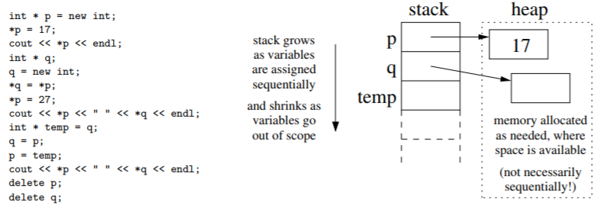
Static memory: variables allocated statically (with the keyword static). They are are not eliminated when they go out of scope. They retain their values, but are only accessible within the scope where they are defined. NOTE: Static variables are not very common.
Automatic memory: memory allocation inside a function when you create a variable. This allocates space for local variables in functions (on the stack) and deallocates it when variables go out of scope. For example: int x; double y;
Dynamic memory: explicitly allocated (on the heap) as needed. This is our focus for today.
operator<( for sorting)

